ABSTRACT
The project is developed to provide a comprehensive and user-friendly Animal Encyclopedia. This platform is designed for people around the world who want to explore and learn about different animal species. Traditional methods of studying animals involve books and scientific journals, but Animal Encyclopedia presents an interactive and highly informative online database, replacing physical references with an engaging, digital experience.

INDEX
SR. No | Contents |  | Page No.
1 | Project Profile |  | 1
2 | Overview of The System |  | 2
 | 2.1 | Scope of Work | 2
 | 2.2 | Objective of the system | 3
 | 2.3 | Scope / Application of the project | 4
 | 2.4 | Advantages of the system | 4
3 | Environment Specification |  | 6
 | 3.1 | Hardware & software specification | 6
 | 3.2 | About technologies | 7
 | 3.3 | About tools | 7
4 | System Planning |  | 10
 | 4.1 | Requirement specification | 10
 | 4.2 | Feasibility study | 10
 | 4.3 | Functional requirement | 11
 | 4.4 | Software process model | 12
 | 4.5 | Risk Analysis | 16
 | 4.6 | Timeline chart | 18
5 | System Design |  | 19
 | 5.1 | UML Diagram | 19
 |  | 5.1.1 Use case Diagram | 19
 |  | 5.1.2 Activity Diagram | 23
 |  | 5.1.3 Sequence Diagram | 32
 | 5.2 | Data Dictionary | 35
6 | Screen layout |  | 40
7 | Testing |  | 55
8 | Limitation & Future enchantment |  | 58
9 | Conclusion |  | 59
10 | References |  | 60

1. Project profile

Project Title | Online Animal encyclopedia
Project Definition | An online animal encyclopedia is a website that gives information about different animals. It tells you where they live, what they eat, how they look, and other fun facts
Duration | 1 month
Front End | CSS,framer motion,materialui,Reactjs
Back End | Mongodb , node.js
Tools | Visual Code studio
Operating System | Microsoft Windows 11
Project Internal Guide | Prof. dhruv mistry

2. OVERVIEW OF THE SYSTEM

2.1. SCOPE OF WORK
- The system must support a structured and categorized database of animal species.
- Users should be able to search and filter information based on categories such as habitat, diet, and conservation status.
- It must provide images, videos, and textual descriptions for each species.
- It must ensure accuracy by sourcing information from credible references.
Definition
An Animal Encyclopedia is a comprehensive reference book or digital resource that provides detailed information about various animal species. It typically includes classifications, habitats, behaviors, diets, and unique characteristics of animals, ranging from mammals and birds to reptiles, amphibians, fish, and insects. These encyclopedias serve as educational tools for students, researchers, and wildlife enthusiasts.
TERM DESCRIPTION
Admin Animal Encyclopedia manages content, updates animal records, and ensures accurate classification and information. They also oversee user access, data security, and system functionality.
User A User is an individual who accesses and interacts with a system, platform, or service for specific purposes. They can view, input, or manage data based on their assigned permissions.
- Faster viewing and retrieval of data: - With this new system data will be viewed faster and data will be retrieved as per the requirements. No information about anybody will be left out.
- Systematic work: - The work done with this system will be systematically and there will be no data loss. With this system work will be done efficiently.
- Less effort: - With this system user will not get much stress on them effortless work will be done and less effort will be given on user.
- Faster and accurate reports and result will be easier to understand: - Whenever user needs to take some important decisions with help of the records the user can take necessary steps, accurate and easy to retrieve.

2.2 Objective of the system
- To create a reliable, comprehensive, and interactive platform for learning about animals.
- To develop a secure system for managing a vast database of species.
- To allow users to explore animals based on scientific classifications.
- To include interactive elements such as quizzes and media content to enhance engagement.

2.3 Scope / Application of the project

Admin:
- Login
- Manage species database
- Add and update animal information
- Upload images and videos
- Manage user feedback
- Logout

User:
- Registration
- Login
- Search for animal details
- View images and videos
- Give feedback
- Logout

2.4 Advantages of the system

- Easy Access to Information: Users can search and browse animal data anytime, anywhere.
- Engaging Multimedia Content: Videos and images enhance learning experiences.
- Accuracy & Credibility: Data is sourced from trusted wildlife organizations and researchers.
- User-Friendly Interface: Simple navigation for all age groups.
- Educational Value: Provides resources for students, researchers, and wildlife enthusiasts.

3. Environment Specification
Implementation is used here to mean the process of converting a new or a revised system design into an operational one. Implementation of a new system to replace an existing one is usually difficult. If not properly planned, there can be many problems. This phase is less creative than system design and is primarily concerned with user training; the type of implementation that is incorporated in the development of the project is implementation of a new application to replace an existing one.

3.1 Hardware and Software Requirements

Web Requirement | Band width – 30 mbps (Minimum).
Development Environment | Processor - Intel(R) Core™ i5  Processor  RAM – 8 GB  SSD – 512GB  Operating System – Windows 11
Client Configuration | Internet – 512 Kbps (Minimum).  Internet Explorer 6.0 and above.
Web hosting | Windows Server 3000 and above

3.2 Technologies used

Front-End | MERN Stack
Back-End | Mongodb,nodejs
Scripting Language | Reactjs
Other Technology | HTML,CSS

3.3 About tools

- Client side Tools
Browser | Internet Explorer 6.6 or Higher, Mozilla Firefox 1.5 or Higher,  Google Chrome etc.
Operating System | Microsoft Windows 7 Professional or Above.
Ram | 512 MB or Higher

- Server side Tools
Processor | Dual core processor, Intel Core i3
Hard Disk | 500 GB

- Development Environment

- PHP

- MySQLI

- PHP: Server Site Scripting Language

- PHP is a server-side scripting language designed for web development but also used as a general-purpose programming language. As of January 2013, PHP was installed on more than 240 million websites (39% of those sampled) and 2.1 million web servers. Originally created by Rasmus Lerdorf in 1994, the reference implementation of PHP (powered by the Zend Engine) is now produced by The PHP Group. While PHP originally stood for Personal Home Page, it now stands for PHP: Hypertext Pre-processor, which is a recursive backronym.

- PHP code can be simply mixed with HTML code, or it can be used in combination with various templating engines and web frameworks. PHP code is usually processed by a PHP interpreter, which is usually implemented as a web server's native module or a Common Gateway Interface (CGI) executable.

- After the PHP code is interpreted and executed, the web server sends resulting output to its client, usually in form of a part of the generated web page; for example, PHP code can generate a web page's HTML code, an image, or some other data. PHP has also evolved to include a command-line interface (CLI) capability and can be used in standalone graphical applications.

- The canonical PHP interpreter, powered by the Zend Engine, is free software released under the PHP License. PHP has been widely ported and can be deployed on most web servers on almost every operating system and platform, free of charge.

- Despite its popularity, no written specification or standard existed for the PHP language until 2014, leaving the canonical PHP interpreter as a de facto standard. Since 2014, there is ongoing work on creating a formal PHP specification.

- PHP development began in 1994 when Rasmus Lerdorf wrote a series of Common Gateway Interface (CGI) binaries in C, which he used to maintain his personal homepage.

- MySQLI: The World's Most Popular Open Source Database

- Many of the applications that a Web developer wants to use can be made easier by the use of a standardized database to store, organize, and access information. MySQLI is an Open Source (GPL) Standard Query Language (SQL) database that is fast, reliable, easy to use, and suitable for applications of any size. SQL is the ANSI-standard database query language used by most databases (though all have their nonstandard extensions).

- MySQLI can easily be integrated into Perl programs by using the Perl DBI (Database Independent interface) module. DBI is an Application Program Interface (API) that allows Perl to connect to and query a number of SQL databases (among them MySQLI, mSQL, PostgreSQL, Oracle, Sybase, and Informix).

- MySQLI is a powerful, sophisticated, and easy-to-use SQL database program. Using Perl and DBI, one can easily create programs to automate database management tasks. With this knowledge, the prospective web designer should be able to construct a database-based (for lack of a better term) web site that is portable, sophisticated, easy to manage, and professional appearing. We have examined only a small subset of all that MySQLI provides.

4. System Planning

4.1Requirement specification

  - Feasibility Study

- The system feasibility can be divided into the following sections:

- Technology and system feasibility
The assessment is based on an outline design of system requirements in terms of Input, Processes, Output, Fields, Programs, and Procedures. This can be quantified in terms of volumes of data, trends, frequency of updating, etc. in order to estimate whether the new system will perform adequately or not.
- Economic feasibility
Economic analysis is the most frequently used method for evaluating the effectiveness of a new system. More commonly known as cost / benefit analysis the procedure is to determine the benefits and savings that are expected from a candidate system and compare them with cost. If a benefit outweighs cost, then the decision is made to design and implement the system.
- Legal feasibility
Determines whether the proposed system conflicts with legal requirements, e.g. a Data Processing system must comply with the local Data Protection Acts
- Operational feasibility
Is a measure of how well a proposed system solves the problems, and takes advantages of the opportunities identified during scope definition and how it satisfies the requirements identified in the requirements analysis phase of system development.
- Schedule feasibility
A project will fail if it takes too long to be completed before it is useful. typically this means estimating how long the system will take to develop, and if it can be completed in a given time period using some methods like payback period.
- Resource feasibility
This involves questions such as how much time is available to build the new system, when it can be built, whether it interferes with normal business operations, type and amount of resources required, dependencies.

4.3 Functional requirement

Users | Modules | Functionality | Description
Admin | Admin | Login | Admin can login to the system.
 |  | Manage candidate | Manage candidate category.
 |  | Manage User | Manage user category.
 |  | Schedule Election | Add schedule for election.
 |  | Show Result | Show all election result.
 |  | Logout | Admin can logout the system.
Candidate | Candidate | Registration | Candidate can registrants to the system.
 |  | Login | Candidate can login to the system.
 |  | Add Manifesto | Candidate can add manifesto for election.
 |  | Update profile | Candidate can update their profile detail.
 |  | Change Password | Candidate can change password.
 |  | Log Out | Candidate can Log out the system.
User | User | Registration | User can registrants to the system.
 |  | Login | User can login to the system.
 |  | View candidate detail | User can view all candidate detail in front.
 |  | Gives vote to candidate | User can give vote to candidate once time.
 |  | Gove feedback | User can give feedback to the system.
 |  | Logout | User can logout the system.

4.4 Software Engineering Model (Spiral Model)

- Spiral Model

- The spiral model combines the idea of iterative development with the systematic, controlled aspects of the waterfall model.
- Spiral model is a combination of iterative development process model and sequential linear development model i.e. waterfall model with very high emphasis on risk analysis.
- It allows for incremental releases of the product, or incremental refinement through each iteration around the spiral.

- Spiral Model design

- The spiral model has four phases. A software project repeatedly passes through these phases in iterations called Spirals.
- Identification:
    - This phase starts with gathering the business requirements in the baseline spiral. In the subsequent spirals as the product matures, identification of system requirements, subsystem requirements and unit requirements are all done in this phase.
    - This also includes understanding the system requirements by continuous communication between the customer and the system analyst. At the end of the spiral the product is deployed in the identified market.
- Design:
    - Design phase starts with the conceptual design in the baseline spiral and involves architectural design, logical design of modules, physical product design and final design in the subsequent spirals.
- Construct or Build:
    - Construct phase refers to production of the actual software product at every spiral. In the baseline spiral when the product is just thought of and the design is being developed a POC (Proof of Concept) is developed in this phase to get customer feedback.
    - Then in the subsequent spirals with higher clarity on requirements and design details a working model of the software called build is produced with a version number. These builds are sent to customer for feedback.

- Evaluation and Risk Analysis:
    - Risk Analysis includes identifying, estimating, and monitoring technical feasibility and management risks, such as schedule slippage and cost overrun. After testing the build, at the end of first iteration, the customer evaluates the software and provides feedback.
- Following is a diagrammatic representation of spiral model listing the activities in each phase:

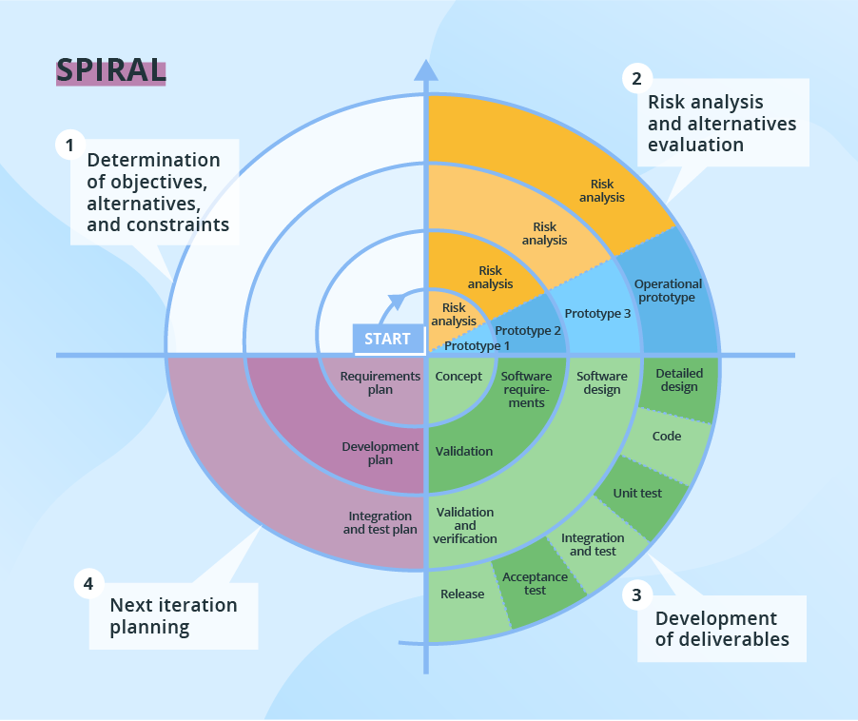

Based on the customer evaluation, software development process enters into the next iteration and subsequently follows the linear approach to implement the feedback suggested by the customer. The process of iterations along the spiral continues throughout the life of the software.
Spiral Model Application
  - Spiral Model is very widely used in the software industry as it is in synch with the natural development process of any product i.e. learning with maturity and also involves minimum risk for the customer as well as the development firms. Following are the typical uses of Spiral model:
  - When costs there are a budget constraint and risk evaluation is important.
  - For medium to high-risk projects.
  - Long-term project commitment because of potential changes to economic priorities as the requirements change with time.
  - Customer is not sure of their requirements which are usually the case.
  - Requirements are complex and need evaluation to get clarity.
  - New product line which should be released in phases to get enough customer feedback.
  - Significant changes are expected in the product during the development cycle.

Spiral Model Pros and Cons

  - The advantage of spiral lifecycle model is that it allows for elements of the product to be added in when they become available or known. This assures that there is no conflict with previous requirements and design.
  - This method is consistent with approaches that have multiple software builds and releases and allows for making an orderly transition to a maintenance activity. Another positive aspect is that the spiral model forces early user involvement in the system development effort.
  - On the other side, it takes very strict management to complete such products and there is a risk of running the spiral in indefinite loop. So the discipline of change and the extent of taking change requests are very important to develop and deploy the product successfully.

- The following table lists out the pros and cons of Spiral SDLC Model:

Pros | Cons
- Changing requirements can be accommodated.  - Allows for extensive use of prototypes  - Requirements can be captured more accurately.  - Users see the system early.  - Development can be divided into smaller parts and more risky parts can be developed earlier which helps better risk management. | - Management is more complex.  - End of project may not be known early.  - Not suitable for small or low risk projects and could be expensive for small projects.  - Process is complex  - Spiral may go indefinitely.  - Large number of intermediate stages requires excessive documentation.

4.5 Risk Analysis

- Schedule Risk:

- Project schedule get slip when project tasks and schedule release risks are not addressed properly.
- Schedule risks mainly affected on project and finally on company economy and may lead to project failure.
- Schedules often slip due to following reasons: Wrong time estimation

    - Resources are not tracked properly. All resources like staff, systems, skills of individuals etc.
    - Failure to identify complex functionalities and time required to develop those functionalities.
  - Unexpected project scope expansions.

- Operational Risks:

- Risks of loss due to improper process implementation, failed system or some external events risks.
- Causes of Operational risks:

  - Failure to address priority conflicts Failure to resolve the responsibilities
  - Insufficient resources
  - No proper subject training
  - No resource planning No communication in team.

- Technical risks:

- A technical risk generally leads to failure of functionality and performance.
- Causes of technical risks are:

  - Continuous changing requirements

    - No advanced technology available or the existing technology is in initial stages.
  - Product is complex to implement.

  - Difficult project modules integration.

- Programmatic Risks:

- These are the external risks beyond the operational limits. These are all uncertain risks are outside the control of the program.

- These external events can be:

  - Running out of fund Market development.
  - Changing customer product strategy and priority.
  - Government rule changes.

4.6 Time Line Chart

Tasks | 1-Mar-2021 To 18-May-2021
Tasks | 1 | 2 | 3 | 4 | 5 | 6 | 7 | 8 | 9
1.Introduction
Requirement Gathering
Analyze Gathered information
Determine Basic functionality
Determine Scope of System
Milestone Completed
2.Planning and Risk analysis
Analyze data for possible risk
Identify potential risk
Determines different modules
Milestone Completed
3.Designing
Design basic interface
Design database table
Design UI model
Milestone Completed
4.Coding and integrated modules
Define code logics
Implementation of logics
Master modules
Transaction modules
Milestone Completed
5.Testing
Validate input data on control
Check accuracy of transaction
Test system with multiple users
Milestone Completed

5. System Design
  - UML Diagram

5.1.1 Use Case Diagram

  - A use case diagram in Unified Modelling Language (UML) is a type of behavioural diagram defined by and created from a use-case analysis. Its purpose is to present a graphical overview of the functionality provided by a system in terms of actors, their goals (represented as use cases), and any dependencies between those use cases.

  - Steps required to understand use-case:

    - What to write about?
    - How much to write about it?
    - How detailed to make our description?
    - How to organize the description?

  - The first step in writing a use case is to define the set of “actors”

Symbol | Symbol Name | Symbol Description
 | Actor | An actor is a person, group, or system that interacts with the use case.  The actor symbol represents a textual explanation of the actor that is created in a document independently from a diagram.
 | Association | A relationship between two elements in the diagram.  Associations between actors and use cases and represented by a solid line.
 | System Boundary | The system boundary separates a system from actors and other systems.  To add elements to a system, create them outside the boundary, and then drag them into the boundary.

- Use case for Admin

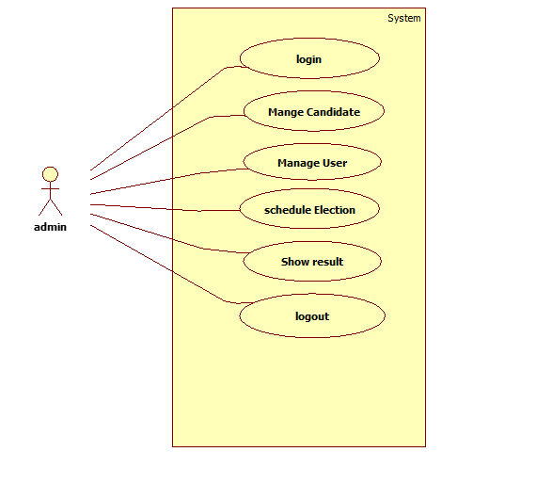

- Use case for Candidate

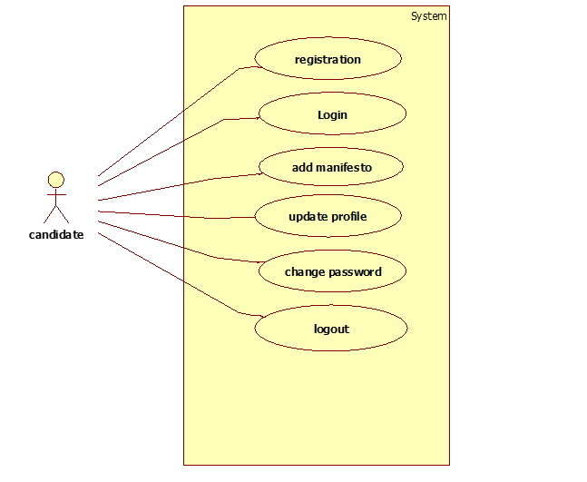

- Use case for user

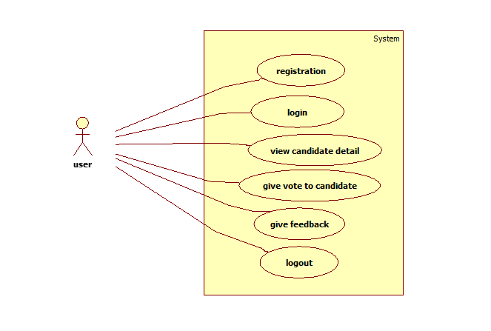

5.1.2 Activity Diagram

- Activity diagram is basically a flow chart to represent the flow form one activity to another activity. The activity can be described as an operation of the system.

- Purpose:

  - Activity diagram use for to represent flow of function.

Symbol | Symbol Name | Symbol Description
 | Black circle | A black circle is the standard notation for an initial state before an activity takes place.  It can either stand alone or you can use a note to further elucidate the starting point.
 | Activity | The activity symbols are the basic building blocks of an activity diagram and usually have a short description of the activity they represent.
 | Join | A join combines two concurrent activities back into a flow where only one activity is happening at a time.
 | Arrows | Arrows represent the direction flow of the flow chart.  The arrow points in the direction of progressing activities.
 | Fork splits | A fork splits one activity flow into two concurrent activities.
 | Diamond | A marker shaped like a diamond is the standard symbol for a decision.  There are always at least two paths coming out of a decision and the condition text lets you know which options are mutually exclusive.
 | Black circle | The black circle that looks like a selected radio button is the UML symbol for the end state of an activity.  As shown in two examples above, notes can also be used to explain an end state.

- Activity Diagram for login

- Activity diagram for candidate registration
Activity diagram for manifesto

Activity diagram for change password

Activity diagram for election Schedule

Activity diagram for user registration

Activity diagram for voting

5.2.5 Sequence Diagram

- Login

- Candidate registration

- Add manifesto

- add election date

- user registration

- vote for candidate

5.2 Data Dictionary

The data dictionary is an organized listing of all data elements that are pertinent to the system, with precise, rigorous definitions so that both user and system analyst will have a common understanding of inputs, outputs, components of stores.

- Format of Data Dictionary

  - Name:

    - The primary name of the data or control item, the data store or an External Entity.

  - Data Type

    - Other names used for the Data type.

  - Size

    - Describe datatype Size.

  - Constraints

    - A give a constraints to the name.

1. Table Name: admin_master

Description: It is used to store user type information.

Column Name | Data type | Size | Constrainst
adminId | int | 11 | Primary Key
adminName | varchar | 40 | NULL
adminPassword | varchar | 10 | NULL

2. Table Name: candidate_manifesto

Description: It is used to store Candidate manifesto information.

Column Name | Data type | Size | Constrainst
manifestoId | int | 11 | Primary Key
candidateId | int | 11 | NULL
manifestoDesc | text |  | NULL

3. Table Name : candidate_master

Description: It is used to store candidate registration detail.

Column Name | Data type | Size | Constrainst
candidateId | int | 11 | Primary Key
candidateName | varchar | 100 | NULL
candidateFatherName | varchar | 100 | NULL
candidateMotherName | varchar | 100 | NULL
candidateDOB | Date |  | NULL
candidateEmail | varchar | 50 | NULL
candidatePassword | varchar | 10 | NULL
candidateContact | varchar | 10 | NULL
candidateAddress | text |  | NULL
candidateEduction | varchar | 50 | NULL
candidateRecord | varchar | 3 | NULL
candidateAnnualIncome | int | 11 | NULL
candidateSign | text |  | NULL
candidateAdhar | text |  | NULL

candidateVoting | text |  | NULL
candidateProfile | text |  | NULL
registerOn | datetime |  | NULL
updateOn | datetime |  | NULL
deketedOn | date |  | NULL
isActive | varchar | 3 | NULL

4. Table Name: client_master

Description: It is used to store User registration detail.

Column Name | Data type | Size | Constrainst
userId | int | 11 | Primary Key
userName | varchar | 100 | NULL
userEmail | varchar | 100 | NULL
userContact | varchar | 10 | NULL
userPassword | varchar | 10 | NULL
userAddress | varchar | 500 | NULL
registeredOn | date |  | NULL
voterId | varchar | 10 | NULL
votingInage | varchar | 100 | NULL
isActive | varchar | 3 | NULL
isVoted | varchar | 3 | NULL

5. Table Name: schedule_master

Description: It is use to add election name and date.

Column Name | Data type | Size | Constrainst
scheduleId | int | 11 | Primary Key
electionName | varchar | 100 | NULL
electionDate | date |  | NULL

6. Table Name: vote_master

Description: It is used to store vote of user.

Column Name | Data type | Size | Constrainst
voterId | Int | 11 | Primary Key
scheduleId | int | 11 | NULL
userId | int | 11 | NULL
candidateId | Int | 11 | NULL
voteDate | date |  | NULL
6.Screen Layout

- Admin Side

- Login Page

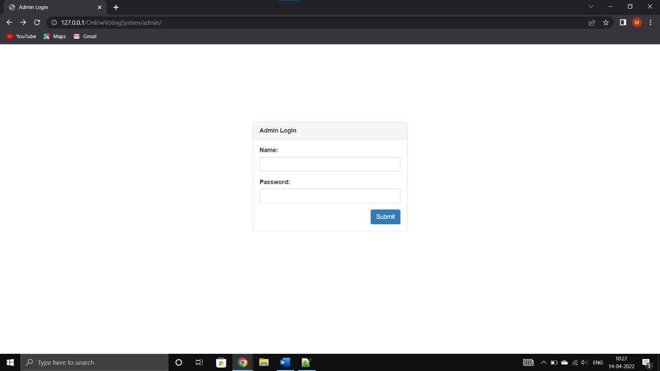

- Description: This page will display Admin login.

- Admin manage candidate

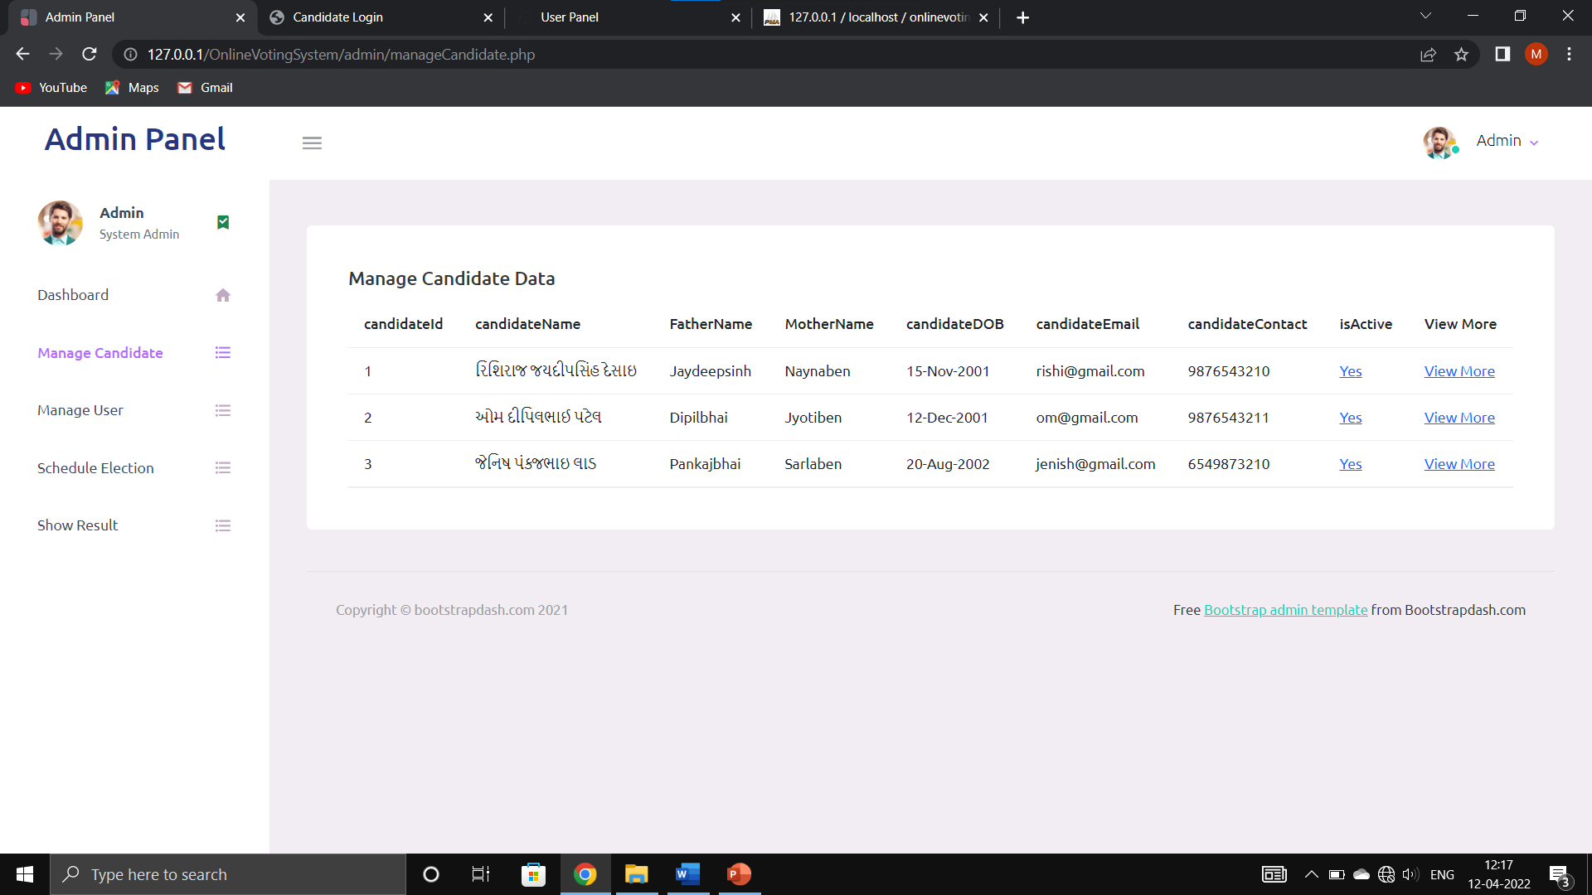

Description: This Page is Display candidate register detail at admin side.

- Manage User

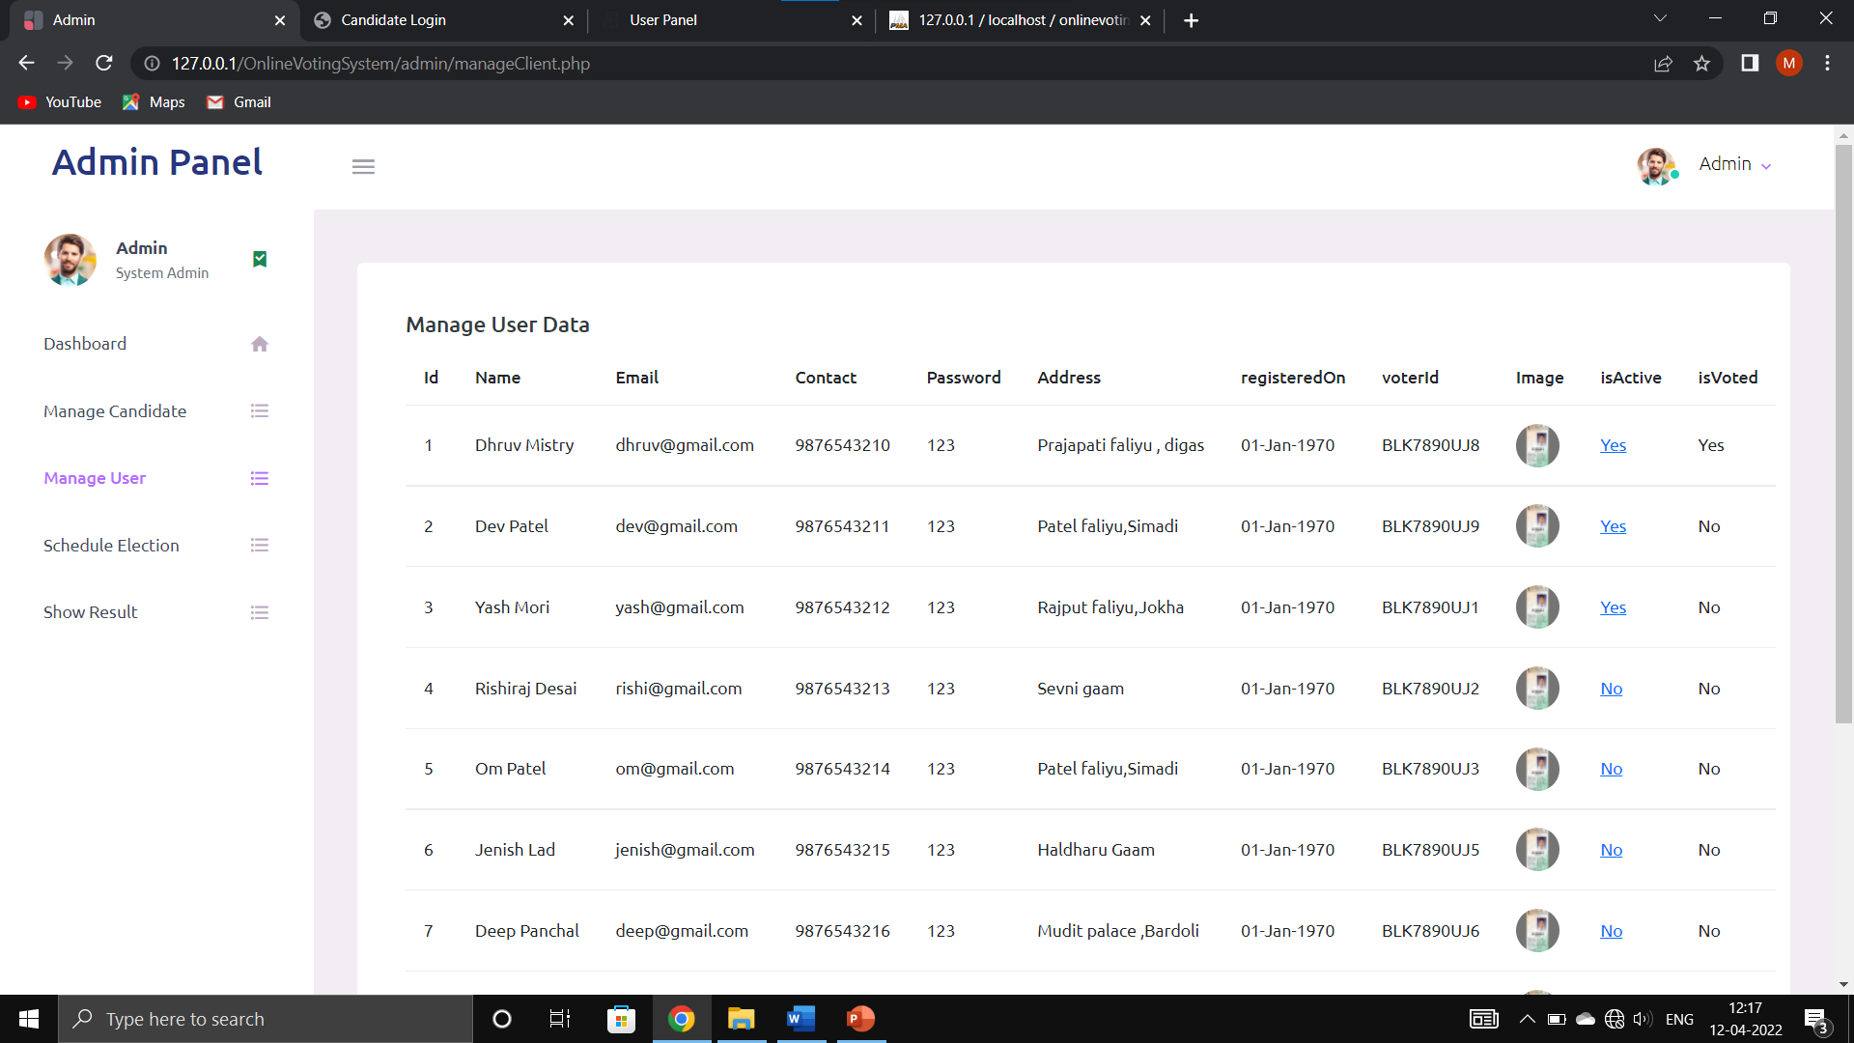

Description: This Page is Display User register Detail.

- Schedule Election

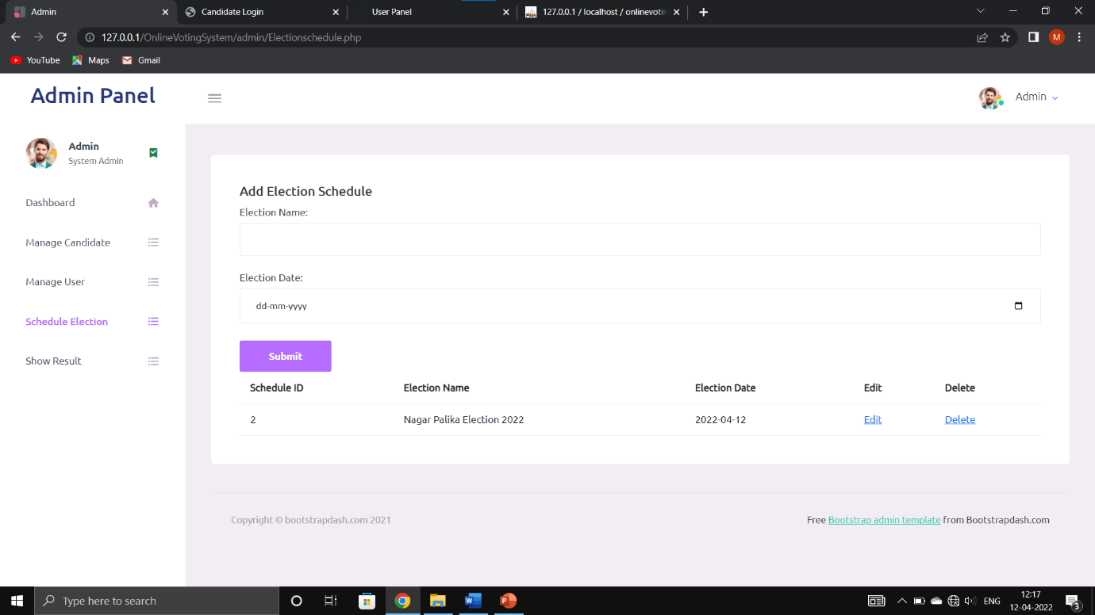

- Description:
Admin can add election schedule for upcoming election.

- Show Result at Admin side

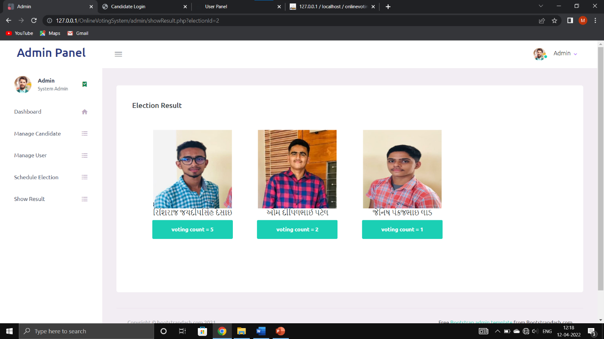

Description: This Page will display result of election.

- Change Password

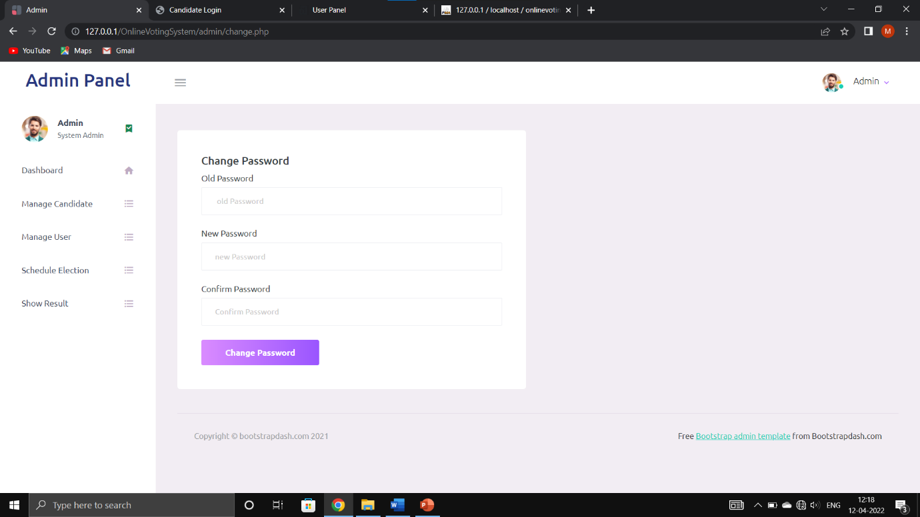

- Description:

This page will display admin change password.

- Candidate Side

- Candidate Registration

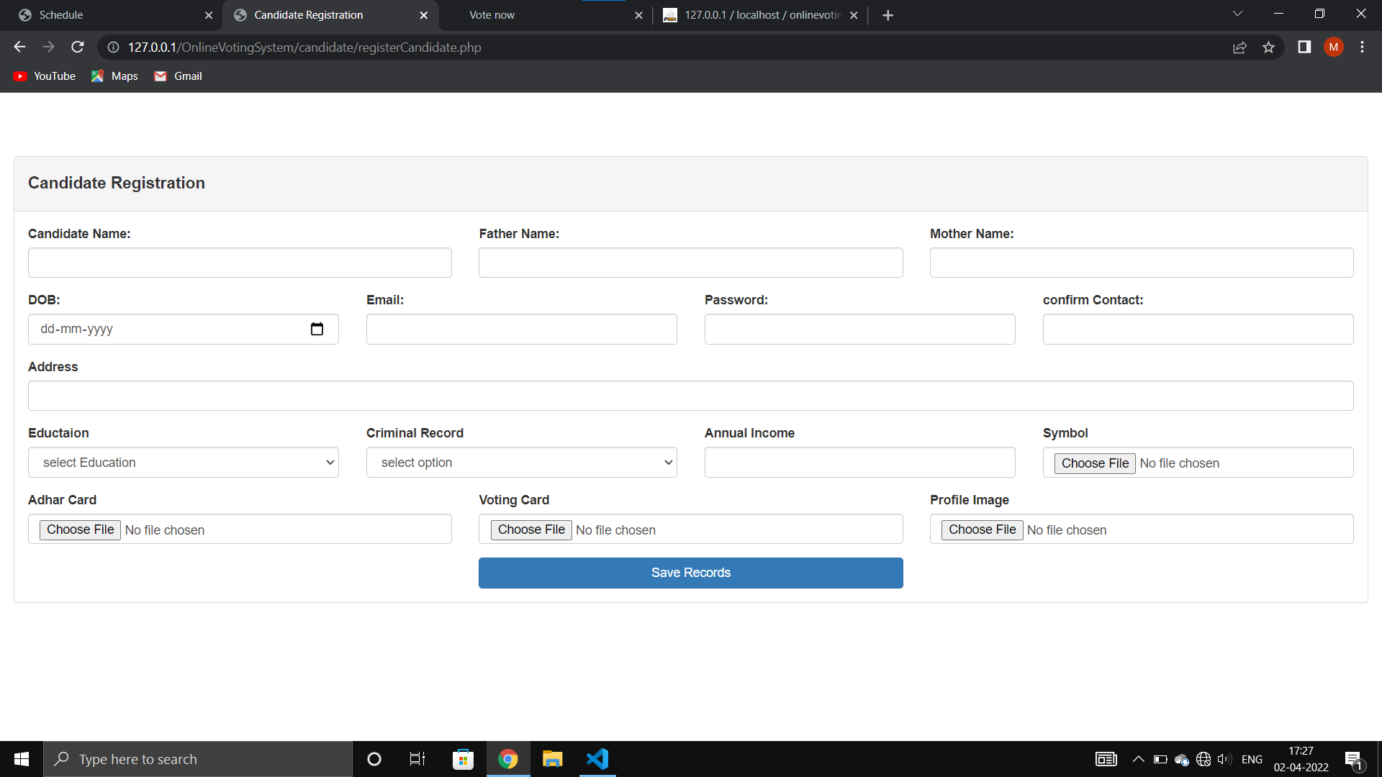

- Description:

In this page candidate can register for Election candidate.

- Candidate Login

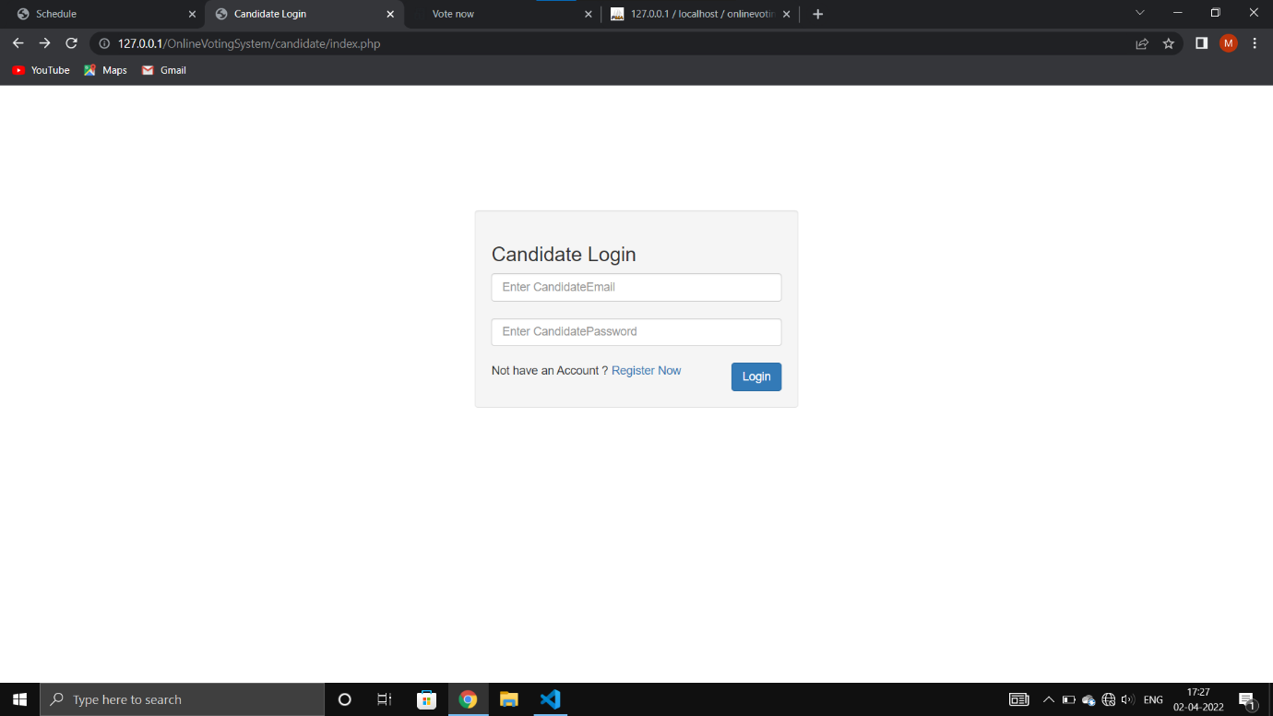

- Description:
In this page candidate can login for the election.

- Add Candidate Manifesto

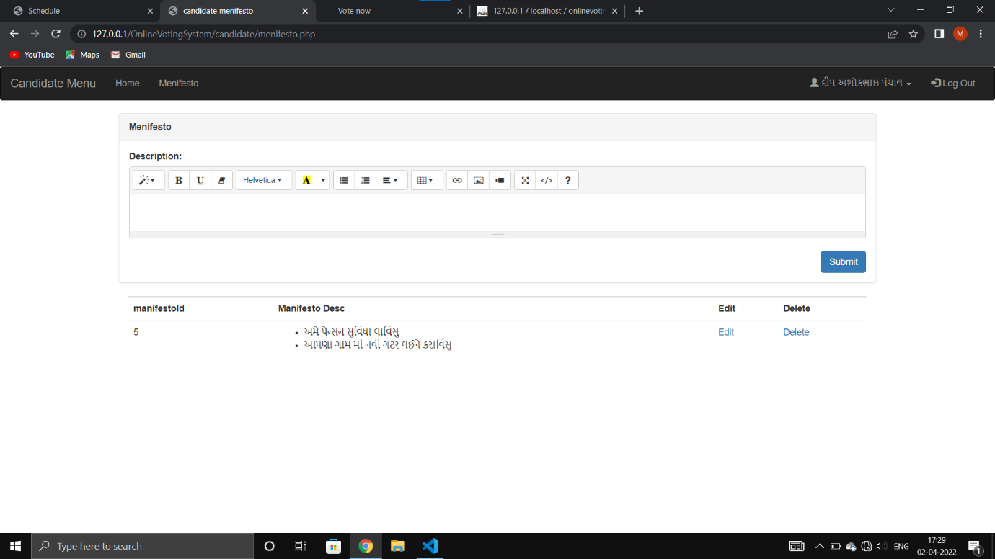

- Description:

In this page candidate can add manifesto description for the election.

- Candidate update profile

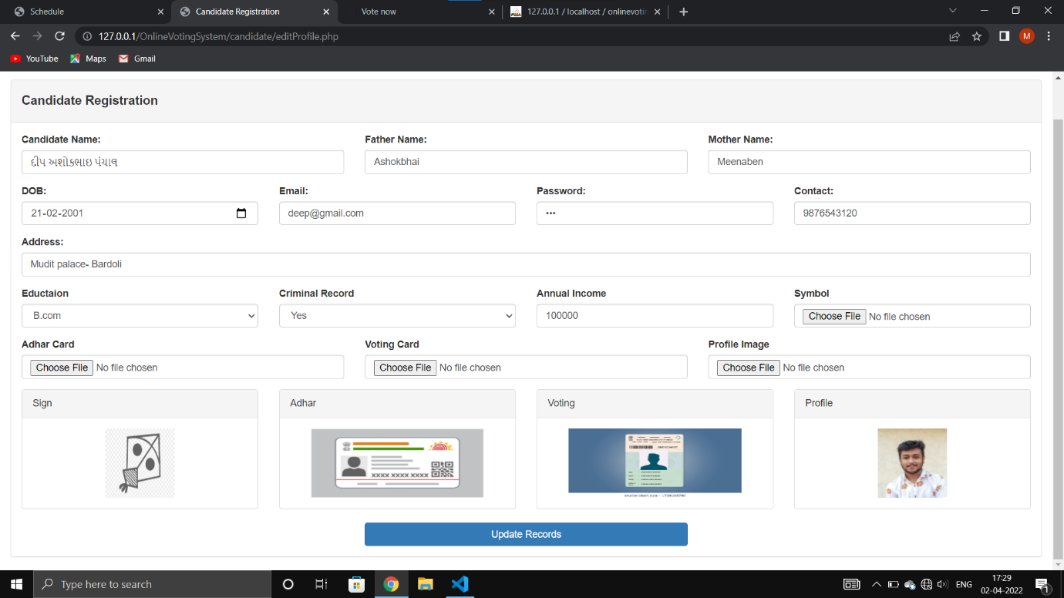

- Description:

In this page candidate can update records.

- User Side

- Standing Candidate List at User side

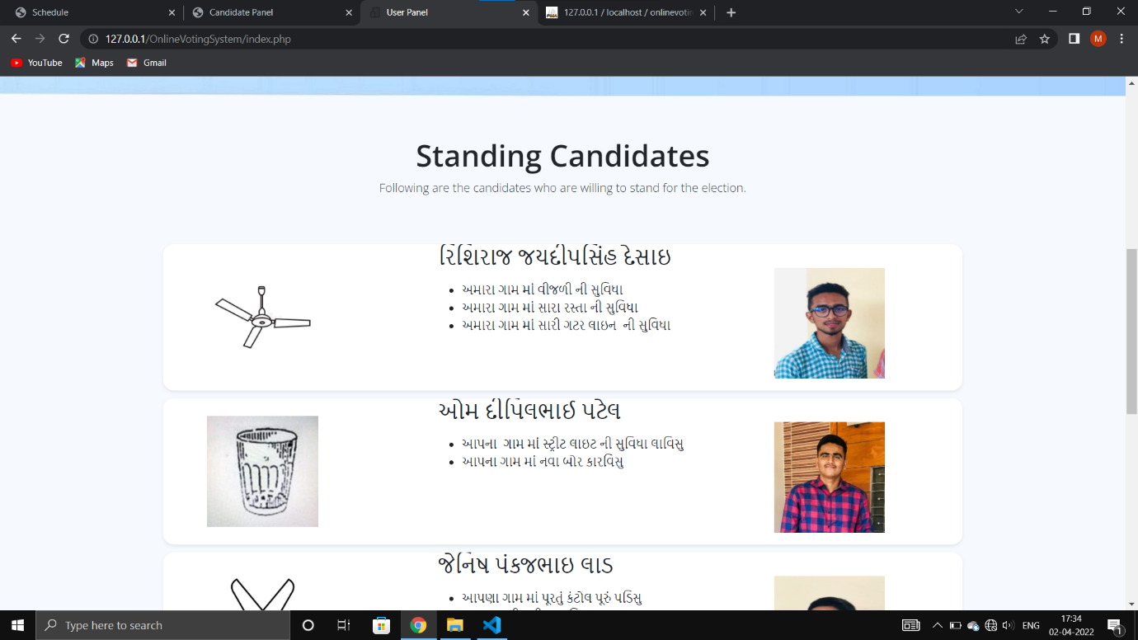

- Description:
This page is display Standing candidate detail.

- User Register and Login Page

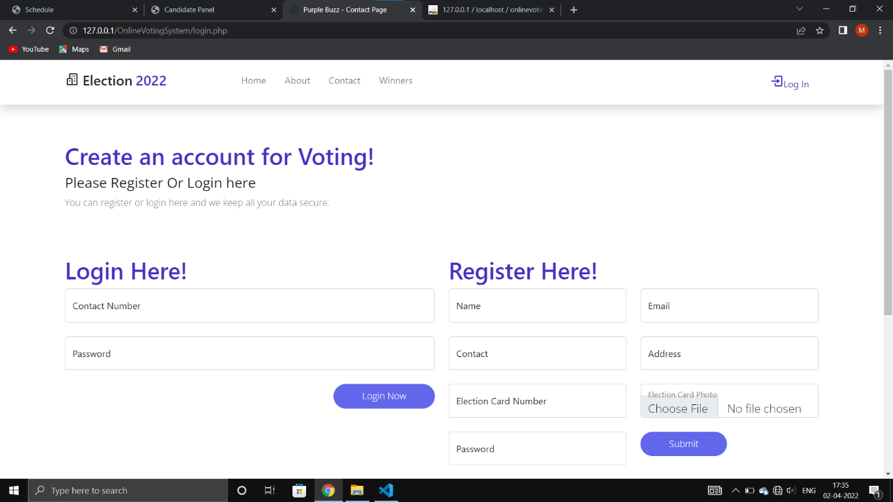

- Description:

In this page first user can register and then login for the voting.

- For voting Candidate Page

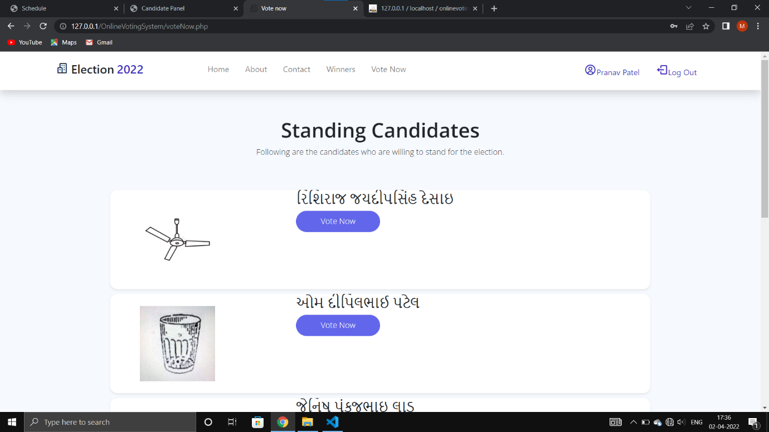

- Description:

And then user can view candidate detail on vote now page for the voting.

- Voted Successfully message

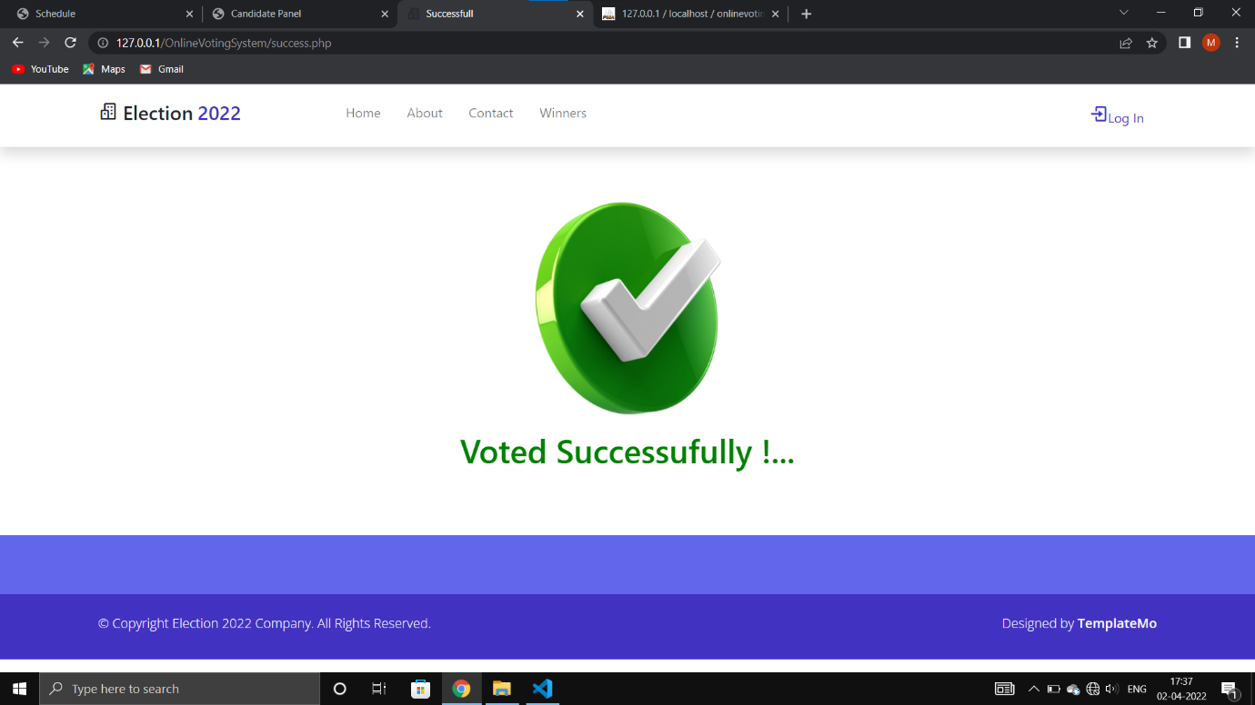

- Description:

User can give the vote then view Successfully voted Message.
.

- Winners List at user side

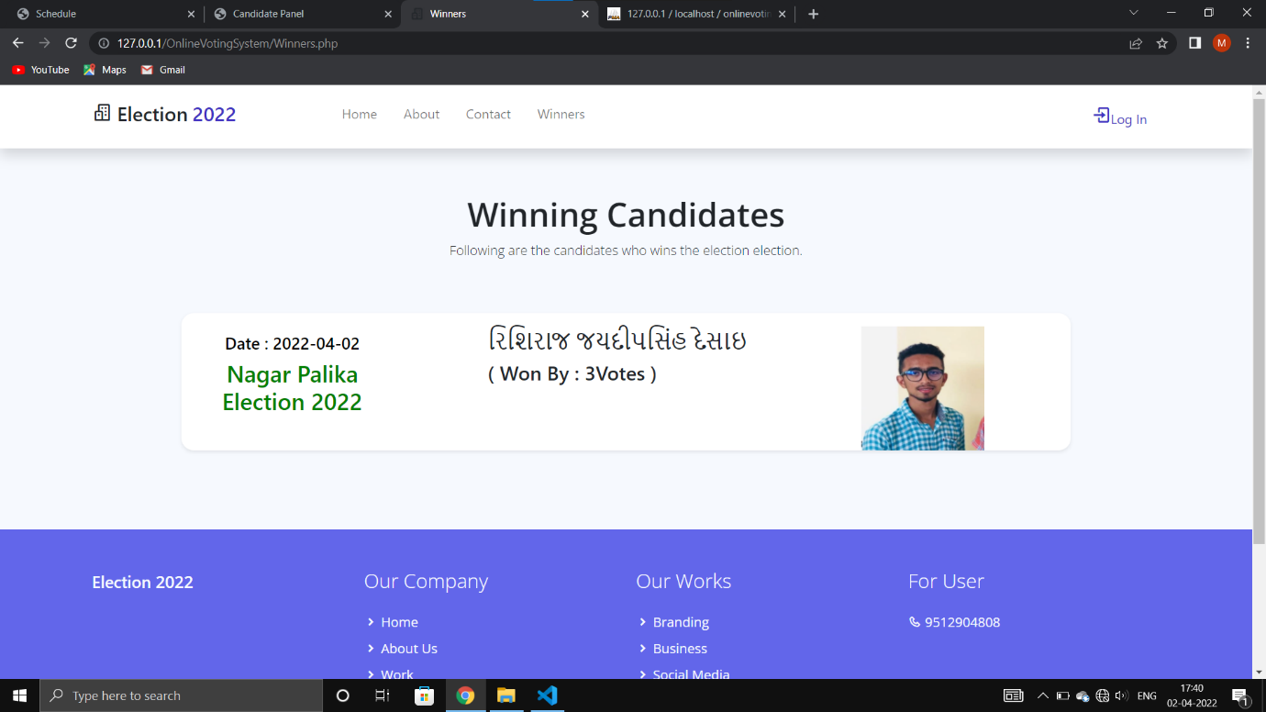

- Description:

This page is display Result of election at user side.

7. TESTING

After finishing the development of any computer based system the next complicated time consuming work is system testing. During the time of testing only the development company can know that, how far the user requirements have been met out, and so on. Following are the some of the testing methods applied to this effective project.

7.1 UNIT TESTING

  - Unit testing means the verification and validation of software. In unit testing (is the smallest part of a module); programmer tests each units of source code for fit to use.
  - Unit testing focuses on verifying the effort on the smallest unit of software-module.
  - The local data structure is examined to ensure that the date stored temporarily maintains its integrity during all steps in the algorithm’s execution.
  - Unit Tested area to ensure that the module operates properly at boundaries established to limit.

7.2 INTEGRATION TESTING

- Integration testing takes input as module that means, it is nothing but the set of unit tested module. It collects them in bigger aggregates and implements tests explained in an integration test plan. Afterwards, distribute as its outcomes to the integrated system which is prepared for system testing.
- In the Integration testing (Modules) the data can be tested across an interface.
- Conducting tests to uncover errors associated with interring while integration testing is a technique for constructing a program structure.

7.3 SPECIFICATION TESTING

- We can set with, what program should do and how it should perform under various conditions. This testing is a comparative study of evolution of system performance and system requirements.

7.4 MODULE LEVEL TESTING

- We can design the various modules for any software and each module contains the small part of the code. If the error will be found at any module, then it encourages the programmer to search and rectify that error without disturbing the other modules.

7.5 VALIDATION TESTING

- Tester is the responsible for Validation of each module, and all the tests done in ‘block box’ testing; it will treat as validation testing.
- It begins after the integration testing is successfully assembled.
- If the software functions in a manner of reasonably accepted by the client then and then only the validation succeeds.
- In this the majority of the validation is done during the data entry operation where there is a maximum possibility of entering wrong data and other validation will be performed in all process where correct details and data should be entered to get the required results.

7.6 RECOVERY TESTING

- Testing which defines the way applications recover from hardware failure and crashes which called as activity testing.
- It detects the where the failure of the software is occurred and provide a number of ways recover the failure module and it send the confirmation about the recovery. In process of recovery testing do not be confused with reliability testing because it tries to discover the point at which failure occurs.

7.7 SECURITY TESTING

- It is a procedure to verify that the system maintains and protects data functionality as intended. Some basic security concepts that need to be covered by security testing are: authentication, integrity, availability, confidentiality, non-repudiation and authorization.
- Security testing is mechanisms which restricts it from offensive penetration and verify that protection mechanism.

7.8 PERFORMANCE TESTING

- The usefulness of computer application, network, and devices can be decided by performance testing.
- In the context of integrated testing system, it checks the performance of software at runtime.
- Performance testing can be also used for calculating the characteristics like reliability, scalability and interoperability.
- It is generally used together with stress testing.

7.9 BLACKBOX TESTING

- It focuses on functional requirement of software. It enables to derive input states that will completely implement every one useful requirement for a program.
- Black box testing is used for finding errors in the categories show below:
- It detects the wrong or misplaced functions. Poorly developed interfaces. It is also used for finding errors in data structures or external database access and performance errors.

8. FUTURE ENHANCEMENT

- Proposed Enhancements:-

  - We are trying to make system more easy to use.

  - We are trying to make system as small as it would be accessed on mobile also.

  - Strong Security.

CONCLUSION

Online Voting Systems have many advantages over the traditional voting system. Some of these advantages are less cost, faster generation results, easy accessibility, accuracy, and low risk of human and mechanical errors. It is very difficult to develop online voting system which can allow security and privacy on the high level. Future development focused to design a system which can be easy to use and will provide security and privacy of votes on acceptable level by proper authentication and processing section. It is easy to use and it is less time consuming. It is very easy to debug.

9. Reference
- Bibliography

  - Beginning PHP 5.3, Matt Doyle, Wrox Publication PHP MySQL B.S SHAH PRAKASHAN

  - Beginning PHP and MySQL, 4th Edition, Apress Publication

- Webography

- During the Development of Project, We have referred following Websites.

- Web site Name:

  - http://php.net/
  - www.w3schools.com
  - http://www.tutorialspoint.com /php

